LAB ASSIGNMENT 11

D. VIDHU SREE

2303A52400

BATCH 41

TASK 01: Stack Implementation for Undo Operations (LIFO)
PROMPT:
Generate a class stack and perform push, pop, peek , is empty and undo methods and also include docstrings.
CODE:
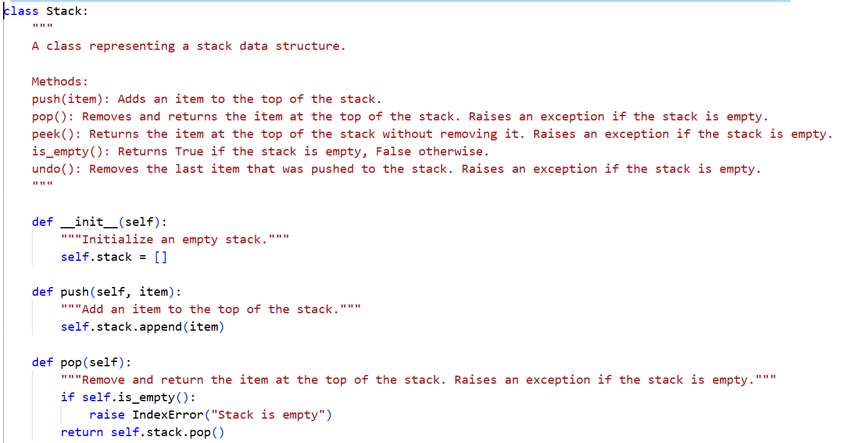
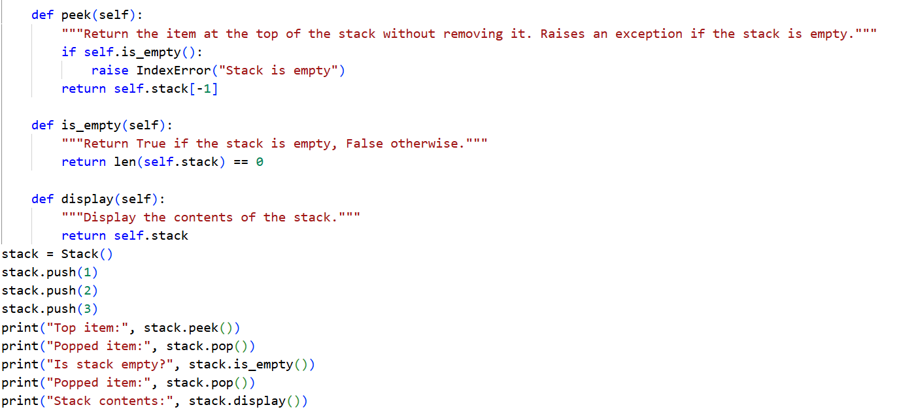
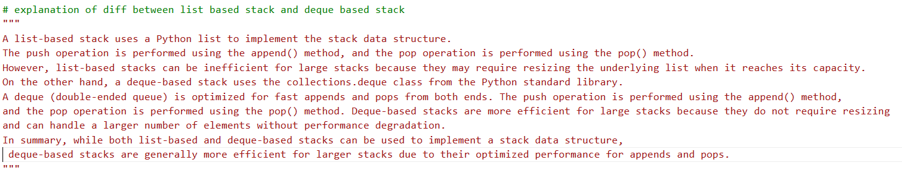
OUTPUT:
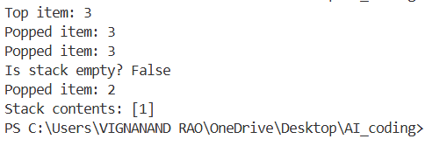
JUSTIFICATION:
A stack works well for undo operations because it follows the Last In, First Out (LIFO) rule. Every time a user performs an action, that action is added to the top of the stack. When the user chooses to undo, the most recent action is removed from the top and reversed. This makes it simple to keep track of actions in the correct order.
Task 2: Queue for Customer Service Requests (FIFO)
PROMPT:
Implement a Queue class for a customer support system where requests are handled in FIFO order using a Python list with enqueue(request), dequeue(), and is_empty(), review its performance, then implement an optimized version using collections.deque, compare time complexity, and justify why deque is better
CODE:
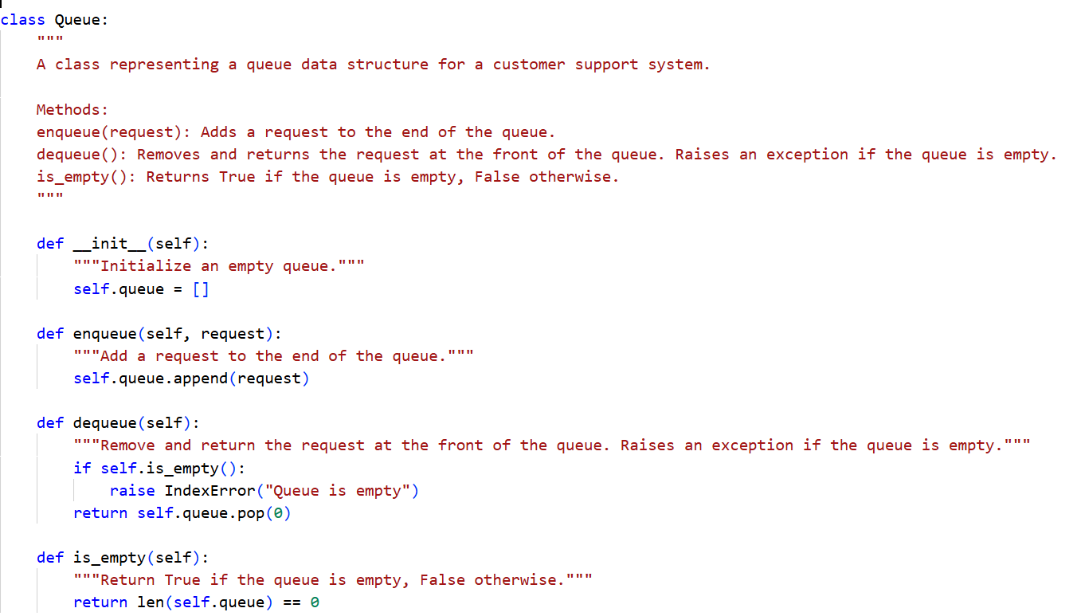
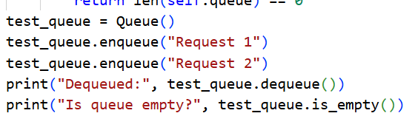
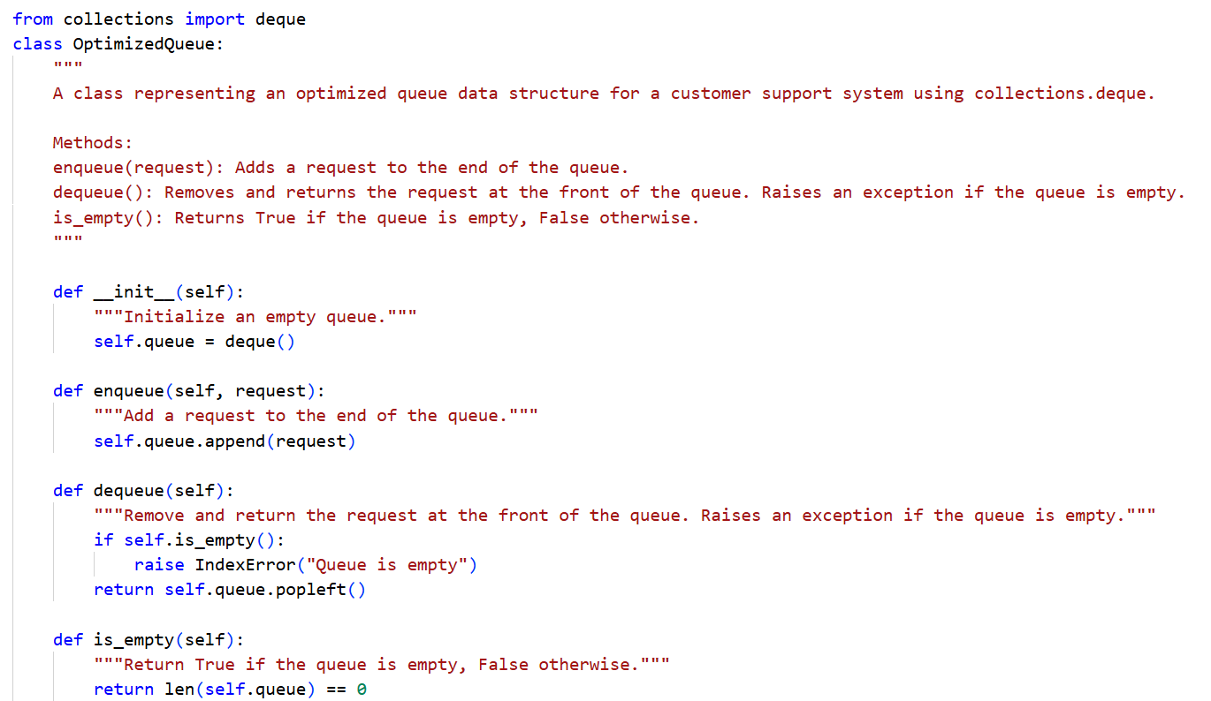
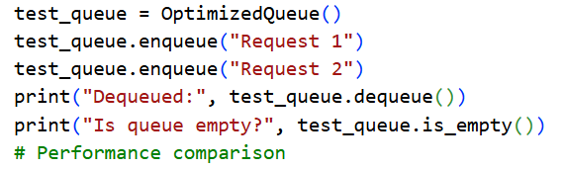
OUTPUT:
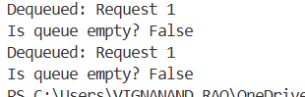
JUSTIFICATION:
In a list-based queue, adding an element (enqueue) takes O(1) time, but removing an element from the front (dequeue) requires O(n) time since all remaining elements need to shift one position to the left. This makes it inefficient for handling a large number of requests. In contrast, a deque-based queue allows both enqueue and dequeue operations in O(1) time because it is implemented using a doubly linked structure. This enables efficient insertion and deletion from both ends without shifting elements, making it more suitable for high-traffic customer support systems.

Task 3: Singly Linked List for Dynamic Playlist Management
PROMPT:
Design a Singly Linked List for managing a music playlist where songs can be added at the end, removed by name, and displayed in order. The implementation should clearly explain how pointers move during insertion and deletion, highlight tricky parts, and include proper test cases for edge conditions like empty list, single node, and deleting the head.
CODE:
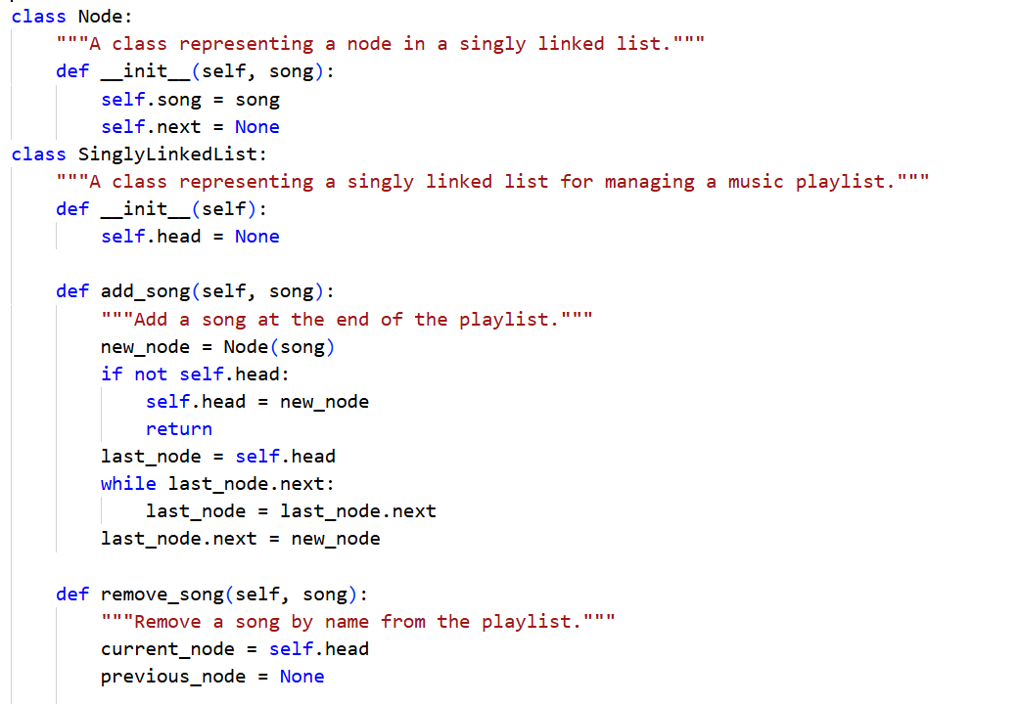
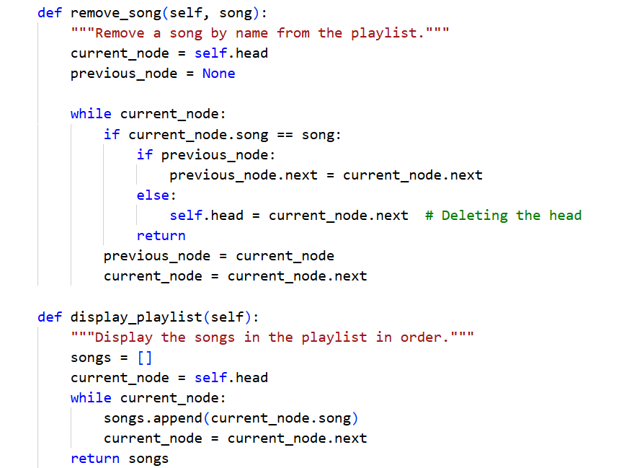
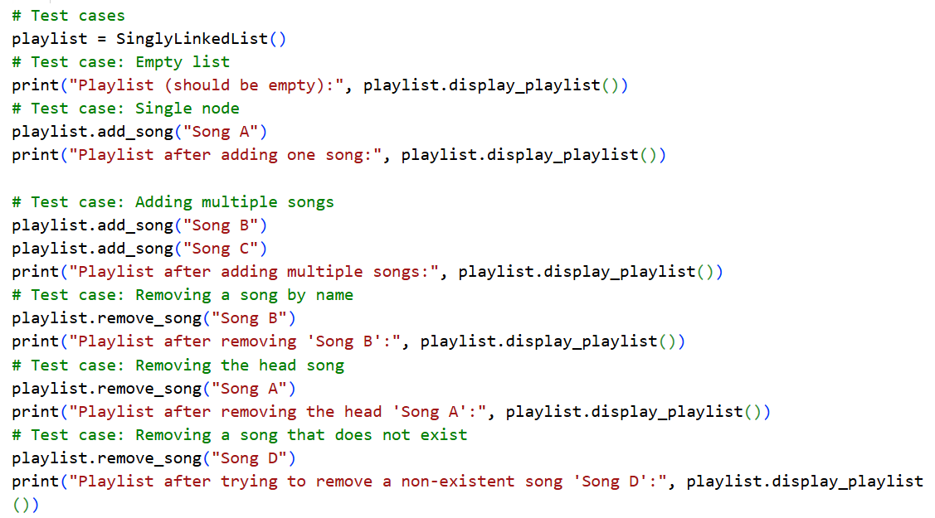

OUTPUT:
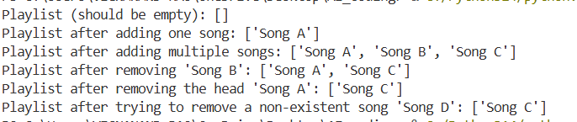
JUSTIFICATION:
A singly linked list is ideal for managing a playlist since songs can be added or removed without reorganizing the entire structure. When inserting a new song, the previous last node must point to the new node. During deletion, special attention is required if the song is at the beginning or in the middle to ensure the links remain intact. By properly handling situations like an empty playlist or a playlist with only one song, the system remains reliable.

Task 4: Binary Search Tree for Fast Record Lookup
PROMPT:
Build a Binary Search Tree (BST) for a student record system where fast searching by roll number is required. Complete the missing methods for insert, search, and inorder traversal, add clear docstrings, and explain how a BST improves search efficiency compared to linear search, including best-case and worst-case performance.
CODE:
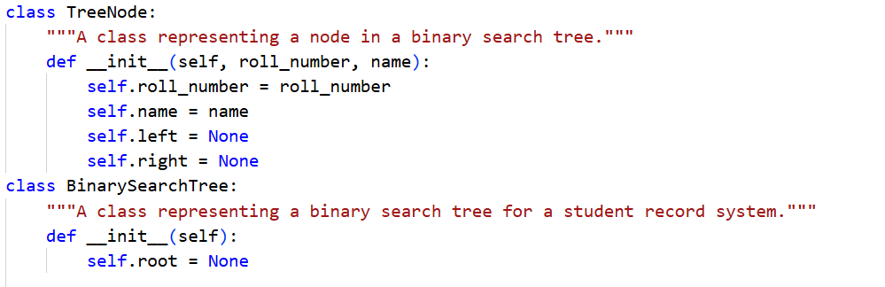
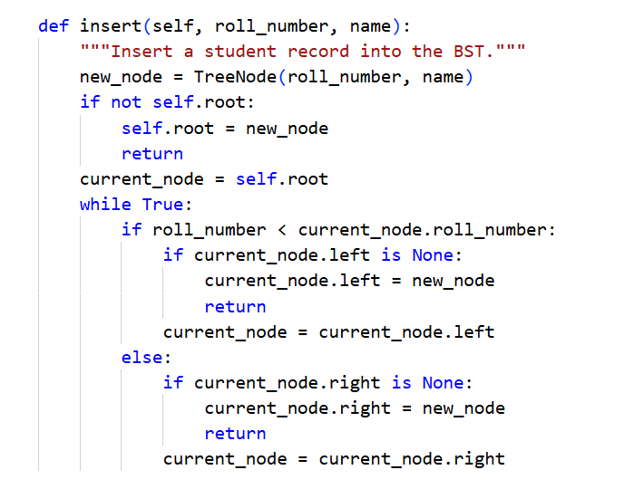
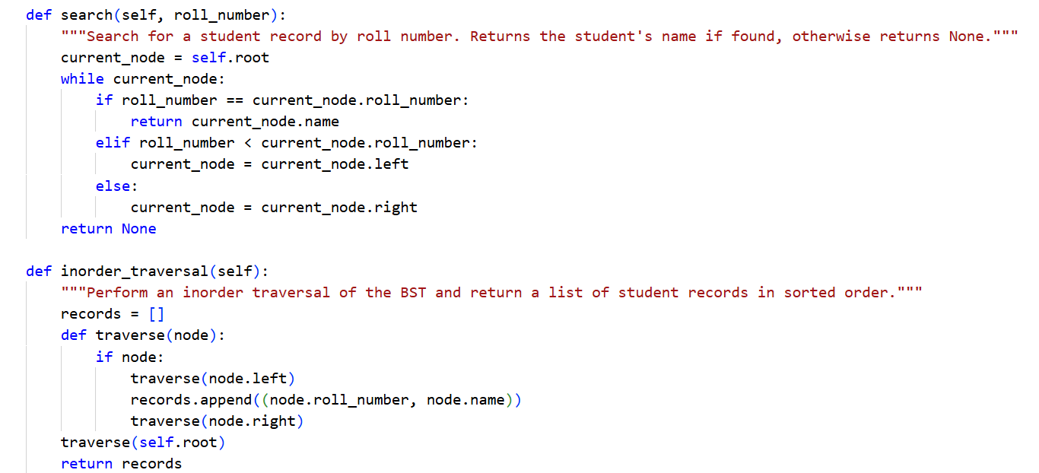
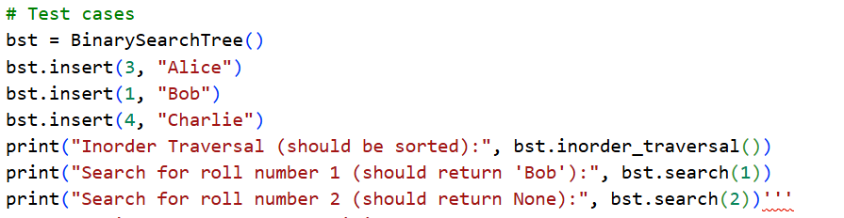
OUTPUT:
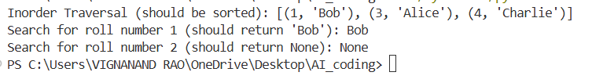
JUSTIFICATION:
A Binary Search Tree enhances searching by splitting data at each level, which reduces the search time to O(log n) when the tree is balanced, unlike linear search that takes O(n) time. However, if the tree becomes skewed or unbalanced, the search performance can drop to O(n), similar to a linear search.

Task 5: Graph Traversal for Social Network Connections
PROMPT:
Create a social network graph using an adjacency list and implement BFS to find nearby friends and DFS to explore deeper connections, with clear comments and explanation of when to use each.
CODE:
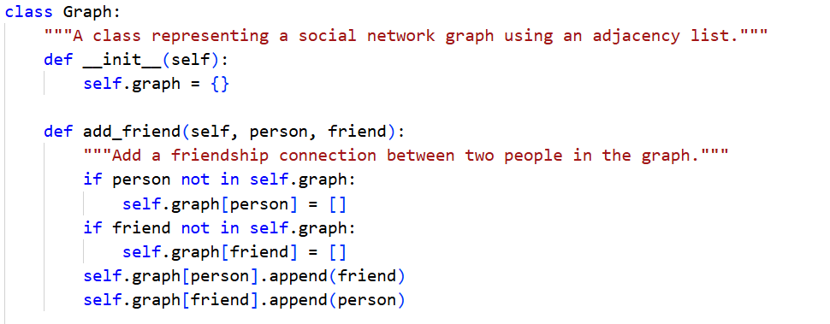
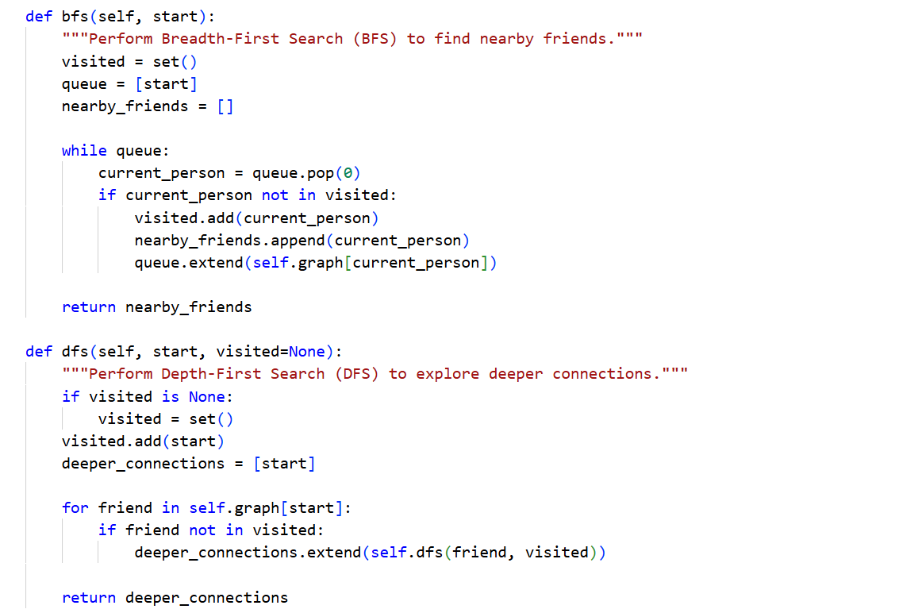
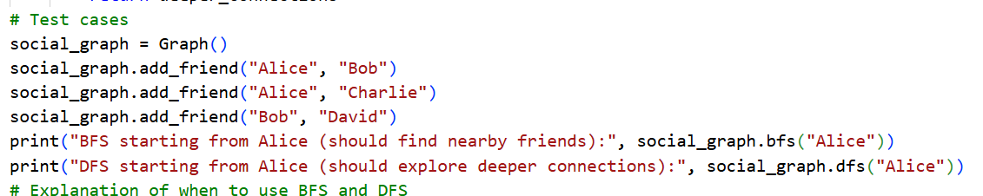
OUTPUT:
JUSTIFICATION:
BFS is effective for finding the closest connections or shortest paths between users because it explores nodes level by level. DFS is more suitable for investigating deeper connections or studying the overall network structure. Recursive DFS is easier to implement, whereas iterative DFS is more practical for large networks since it prevents stack overflow caused by deep recursion.

